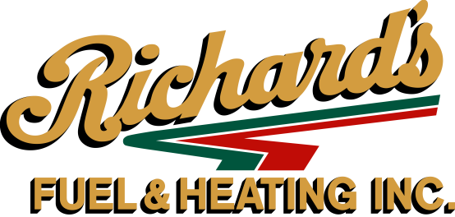
79 Union Street Rear 2, Easthampton, MA 01027
413-527-0194 www.richardsfuel.com

PREPAY--SIMPLE AS 1-2-3 (Fixed price does not go up or come down.)
CASH OR CHECK PAYMENT
- Desired gallons ____________ X $2.149 per gallon = $_____________________
300 Gallon Minimum – Quantities Limited!!!!
Minus any credit you have on account - ___________= $__________________ (Due Richard’s)
Call our office to determine any credit balance you might have.
CREDIT CARD PAYMENT – Visa, Master Card or Discover only
1- Desired gallons____________ X $2.199 per gallon = $_________________________
300 Gallon Minimum – Quantities Limited!!!
Minus any credit you have on account -____________= $__________________ (Due Richard’s)
Call our office to determine any credit balance you might have.
Name on Credit Card ______________________________
Credit Card Number _______________________________
Expiration Date ______________ Security Code__________
QUANTITY LIMITED – PRICE SUBJECT TO CHANGE – THIS IS YOUR BILL!!
- Sign this form and return both copies with payment as soon as possible. We will return one copy for your records signed and marked paid. (No form will be accepted without signature) Quantities limited while supplies last! First-come-first-serve.
-Oil available for delivery from June 19, 2017 – April 30, 2018. Any credit balance will revert to a dollar amount and can be used on future oil purchases at the market price on the day of delivery-NO REFUNDS!
-All payments must be received as soon as possible while supplies last. First-come, first-serve.
-All previous balances must be paid in full.
-Customers selecting this plan agree to purchase their complete fuel needs from Richard’s Fuel & Heating. Penalty for not fulfilling this contract will be $1.00 per gallon for gallons not delivered on contract according to degree day needs.
-If you do not select this offer, we will continue to deliver your fuel needs at our market pricing, at time of delivery. Note—we will continue to offer a $.15 per gallon discount off our posted price, if payment is made within 10 days if paying by cash or check, or deduct $.10 per gallon off posted price, if paying with Visa, Master Card or Discover within 10 days (providing your account has no unpaid balances.) The $.15 or $.10 per gallon discount does not apply to Prepaid Plan.

NAME (PLEASE PRINT) ____________________________________

ADDRESS _____________________________________Home Phone______________

CITY ____________________________ZIP __________Cell Phone________________
PLEASE CHECK ONE OF THE FOLLOWING:
AUTOMATIC DELIVERY __________ WILL CALL _____________
Note: automatic delivery will continue until we are notified otherwise by you. Automatic delivery is not set up only for the life of this contract. Deliveries will continue even if you run out of contracted gallons.
I agree to the terms and conditions listed above and understand how the fixed price and delivery service works. I realize that if subsequent offers are made at lower pricing this contract will NOT be adjusted. This form must be signed!

SIGNATURE ___________________________ DATE________________
Office use only
RICHARD’S FUEL & HEATING VERIFIES AND ACCEPTS THIS CONTRACT SIGNATURE_________________________________DATE___________________
(We will return one copy to you once order is accepted.)
SUPPLY IS LIMITED – PRICE IS SUBJECT TO CHANGE

